SKR & SKR GOVT COLLEGE FOR WOMEN (A) KADAPA
DEPARTMENT OF BIOCHEMISTRY
BOS Meeting
PROGRAMME: B.Sc.
COURSE: BMC (Biochemistry, Microbiology, Chemistry)

2021-2022
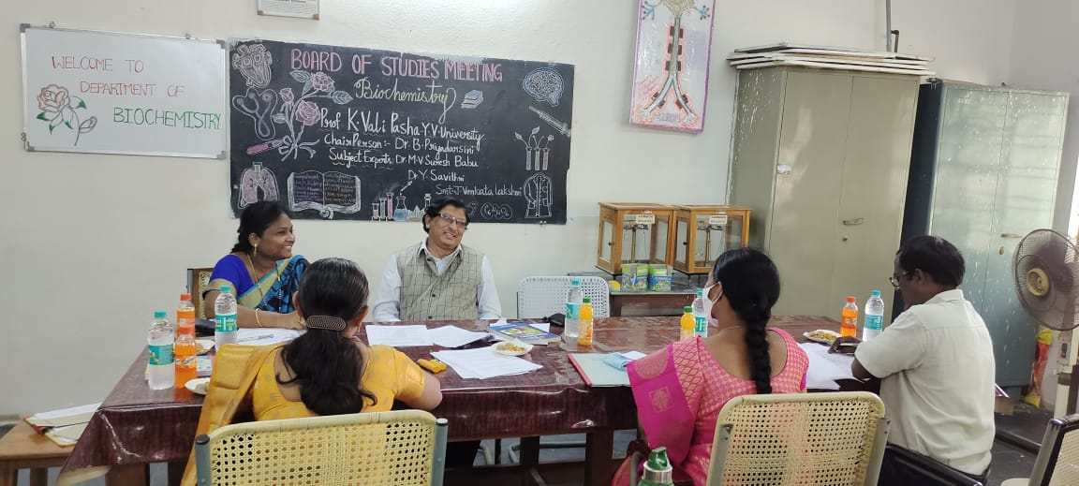

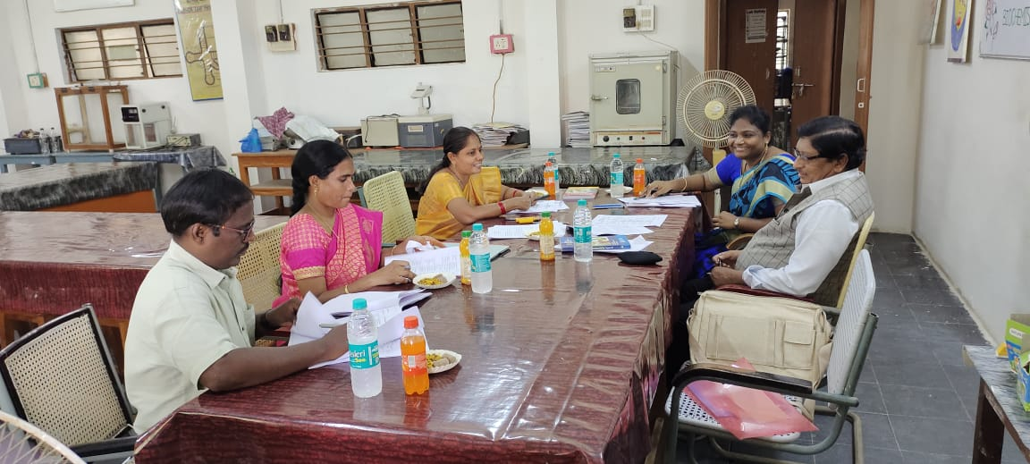

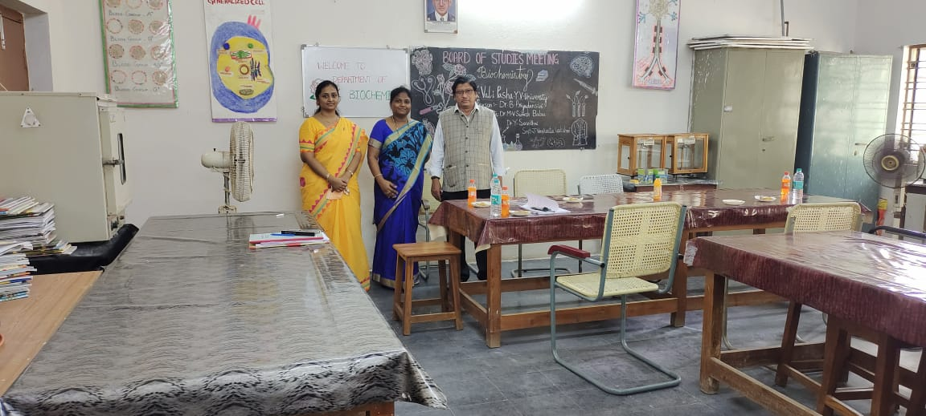
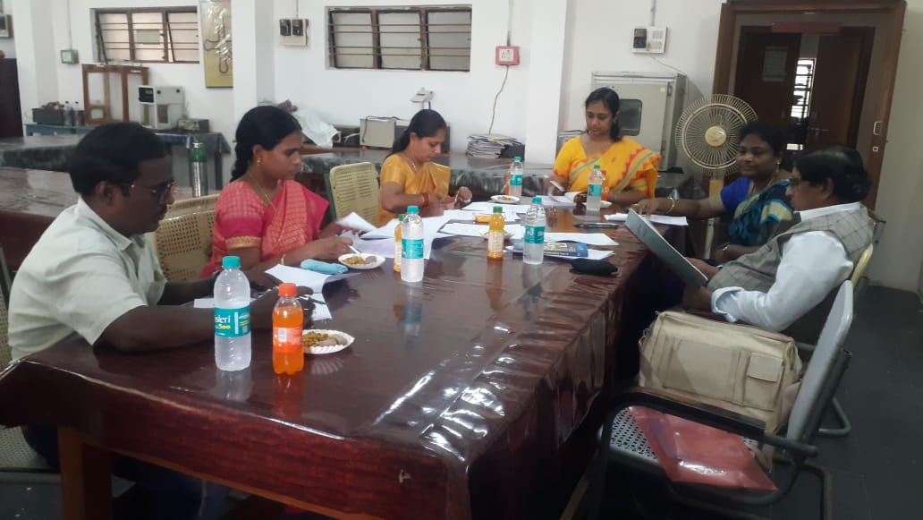
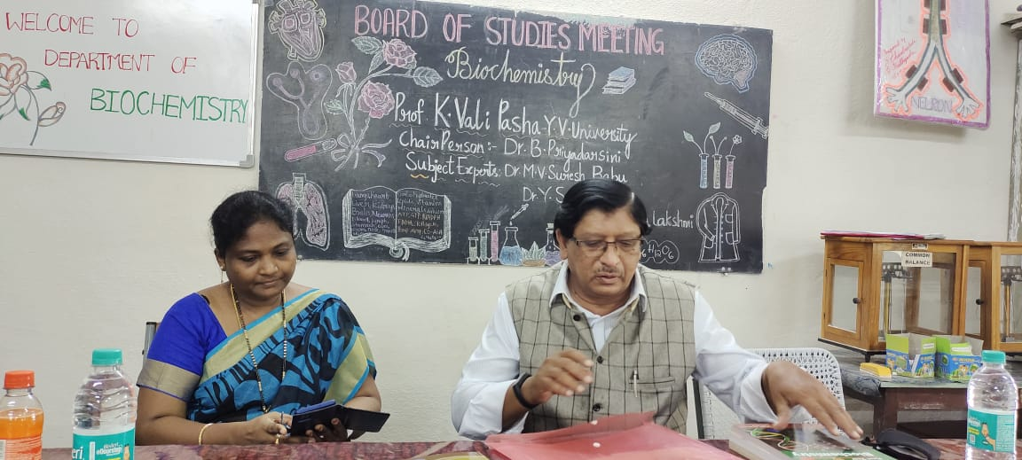

S.K.R & S.K.R
GOVT. DEGREE COLLEGE FOR WOMEN (A) - KADAPA
Re accredited by NAAC with B Grade
DEPARTMENT OF BIO-CHEMISTRY (BOS – 2021 -2022 )

Constitution of Board of Studies in Bio-Chemistry
This Board of Studies in Bio-Chemistry has been constituted by the Principal SKR&SKR Govt. College for Women (A), Kadapa, as per UGC Autonomous guidelines of XII plan (2012-2017)
S.No. | Category | Name and Designation | Chairperson/  Member
01 | In charge of the Dept. of Biochemistry | Smt.Dr, B.Priyadarsini  Lect. in Botany, SKR&SKR GDC Women(A)-Kadapa: | Chairperson
2 | One expert Nominated by the Vice-Chancellor  Y.V.U. Kadapa | Dr. K.Valipasha  . Professor:  Dept. of Biochemistry,  YVU, Kadapa | University Nominee
3 | Faculty Members | P. Laveena  Lect. in Biochemistry | Member
4 | Two Experts from outside the college  College to be nominated by the Academic Council | . Dr. M.V. Suresh Babu  Asst. Professor in Botany  GDC  Rajampet:Cell:9966791906 | Subject Expert Member
4 |  | Dr. Y. Savithri  Lect. in Zoology:8985513433  Govt. College for Men, Kadapa | Subject Expert Member
5 | One Representative from Industry/  Corporate Sector | G.Shesha Reddy,B tech  Mani group of industries  Kadapa | Member
6 | One P.G. Meritorious Alumnus | Smt.J. Venkata Lakshmi  Lect.in chemistry  GDC for Men(A) ,Kadapa | Member

Principal
SKR & SKR Govt. College for Women (A)
Kadapa

